**Comparative Infographic: TDD vs. BDD vs. FDD**

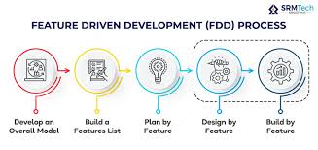

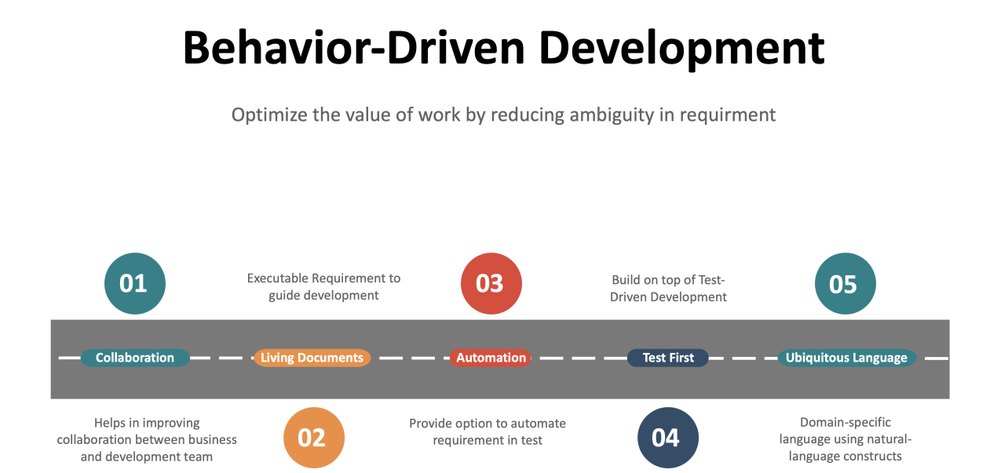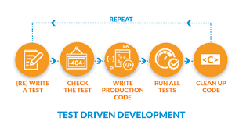

**Test-Driven Development (TDD):**

**Approach:**

Write Tests First: Developers write tests before writing the actual code.

Iterative: Small units of code are developed incrementally, with tests driving each iteration.

Focus on Code: Primarily focuses on ensuring code functionality and reliability.

**Benefits:**

Early Bug Detection: Bugs are caught early in the development process, reducing overall debugging time.

Improved Code Quality: TDD encourages modular, testable code, leading to better design and maintainability.

Regression Prevention: Tests act as a safety net, allowing developers to refactor code confidently.

**Suitability:**

Ideal for projects where requirements are clear and well-defined.

Best suited for teams with strong technical expertise and discipline.

**Behavior-Driven Development (BDD):**

**Approach:**

Define Behavior: Focuses on defining behavior using natural language specifications.

Collaborative: Involves collaboration between developers, testers, and stakeholders to define requirements.

User-Centric: Specifications are written from a user's perspective, focusing on behavior over implementation details.

**Benefits:**

Shared Understanding: BDD promotes clear communication and shared understanding among team members.

Alignment with Business Goals: Specifications are closely tied to business objectives, ensuring alignment between development and business goals.

Improved Test Coverage: BDD encourages writing comprehensive tests that cover both functional and non-functional requirements.

**Suitability:**

Well-suited for projects with complex business logic and user interactions.

Ideal for teams that value collaboration and communication.

**Feature-Driven Development (FDD):**

**Approach:**

Feature-Centric: Breaks down development into small, manageable features.

Phased Development: Development is divided into specific phases: modeling, design, implementation, and testing.

Focus on Deliverables: Emphasizes delivering working features at regular intervals.

**Benefits:**

Incremental Delivery: FDD enables the early delivery of valuable features, providing rapid feedback to stakeholders.

Clear Roles and Responsibilities: Roles and responsibilities are clearly defined, promoting efficiency and accountability.

Scalability: FDD is scalable and well-suited for large, complex projects with multiple teams.

**Suitability:**

Best suited for large-scale projects with evolving requirements.

Ideal for teams that value structured development processes and clear milestones.

**Conclusion:**

Each methodology—TDD, BDD, and FDD—offers unique approaches and benefits. The choice of methodology depends on project requirements, team dynamics, and organizational goals. Understanding the differences between these methodologies can help teams select the most suitable approach for their software development projects.